**Name – Pawar Shrikant Sanjeev**

**SE IT**

**Roll No.47**

**CG Lab**

**Assignment No: 5 (Sutherland Polygon Clipping)**

**Code:**

**#include<iostream>**

**#include<GL/gl.h>**

**#include<GL/glu.h>**

**#include<GL/glut.h>**

**#include<math.h>**

**using namespace std;**

**typedef struct**

**{**

**float x;**

**float y;**

**}PT;**

**int n;**

**int i,j;**

**PT p1,p2,p[20],pp[20];**

**void left()**

**{**

**i=0;j=0;**

**for(i=0;i<n;i++) {**

**if(p[i].x<p1.x && p[i+1].x>=p1.x) {**

**if(p[i+1].x-p[i].x!=0) {**

**pp[j].y=(p[i+1].y-p[i].y)/(p[i+1].x-p[i].x)*(p1.x-p[i].x)+p[i].y;**

**}**

**else {**

**pp[j].y=p[i].y;**

**}**

**pp[j].x=p1.x;**

**j++;**

**pp[j].x=p[i+1].x;**

**pp[j].y=p[i+1].y;**

**j++;**

**}**

**if(p[i].x>=p1.x && p[i+1].x>=p1.x) {**

**pp[j].y=p[i+1].y;**

**pp[j].x=p[i+1].x;**

**j++;**

**}**

**if(p[i].x>=p1.x && p[i+1].x<p1.x) {**

**if(p[i+1].x-p[i].x!=0) {**

**pp[j].y=(p[i+1].y-p[i].y)/(p[i+1].x-p[i].x)*(p1.x-p[i].x)+p[i].y;**

**}**

**else**

**{**

**pp[j].y=p[i].y;**

**}**

**pp[j].x=p1.x;**

**j++;**

**}**

**}**

**for(i=0;i<j;i++)**

**{**

**p[i].x=pp[i].x;**

**p[i].y=pp[i].y;**

**}**

**p[i].x=pp[0].x;**

**p[i].y=pp[0].y;**

**n=j;**

**}**

**void right()**

**{**

**i=0;j=0;**

**for(i=0;i<n;i++)**

**{**

**if(p[i].x>p2.x && p[i+1].x<=p2.x) {**

**if(p[i+1].x-p[i].x!=0) {**

**pp[j].y=(p[i+1].y-p[i].y)/(p[i+1].x-p[i].x)*(p2.x-p[i].x)+p[i].y;**

**}**

**else**

**{**

**pp[j].y=p[i].y;**

**}**

**pp[j].x=p2.x;**

**j++;**

**pp[j].x=p[i+1].x;**

**pp[j].y=p[i+1].y;**

**j++;**

**}**

**if(p[i].x<=p2.x && p[i+1].x<=p2.x) {**

**pp[j].y=p[i+1].y;**

**pp[j].x=p[i+1].x;**

**j++;**

**}**

**if(p[i].x<=p2.x && p[i+1].x>p2.x) {**

**if(p[i+1].x-p[i].x!=0) {**

**pp[j].y=(p[i+1].y-p[i].y)/(p[i+1].x-p[i].x)*(p2.x-p[i].x)+p[i].y;**

**}**

**else**

**{**

**pp[j].y=p[i].y;**

**}**

**pp[j].x=p2.x;**

**j++;**

**}**

**}**

**for(i=0;i<j;i++) {**

**p[i].x=pp[i].x;**

**p[i].y=pp[i].y;**

**}**

**p[i].x=pp[0].x;**

**p[i].y=pp[0].y;**

**}**

**void top()**

**{**

**i=0;j=0;**

**for(i=0;i<n;i++){**

**if(p[i].y>p2.y && p[i+1].y<=p2.y){**

**if(p[i+1].y-p[i].y!=0){**

**pp[j].x=(p[i+1].x-p[i].x)/(p[i+1].y-p[i].y)*(p2.y-p[i].y)+p[i].x;**

**}**

**else**

**{**

**pp[j].x=p[i].x;**

**}**

**pp[j].y=p2.y;**

**j++;**

**pp[j].x=p[i+1].x;**

**pp[j].y=p[i+1].y;**

**j++;**

**}**

**if(p[i].y<=p2.y && p[i+1].y<=p2.y) {**

**pp[j].y=p[i+1].y;**

**pp[j].x=p[i+1].x;**

**j++;**

**}**

**if(p[i].y<=p2.y && p[i+1].y>p2.y){**

**if(p[i+1].y-p[i].y!=0) {**

**pp[j].x=(p[i+1].x-p[i].x)/(p[i+1].y-p[i].y)*(p2.y-p[i].y)+p[i].x;**

**}**

**else**

**{**

**pp[j].x=p[i].x;**

**}**

**pp[j].y=p2.y;**

**j++;**

**}**

**}**

**for(i=0;i<j;i++)**

**{**

**p[i].x=pp[i].x;**

**p[i].y=pp[i].y;**

**}**

**p[i].x=pp[0].x;**

**p[i].y=pp[0].y;**

**n=j;**

**}**

**void bottom()**

**{**

**i=0;j=0;**

**for(i=0;i<n;i++)**

**{**

**if(p[i].y<p1.y && p[i+1].y>=p1.y) {**

**if(p[i+1].y-p[i].y!=0) {**

**pp[j].x=(p[i+1].x-p[i].x)/(p[i+1].y-p[i].y)*(p1.y-p[i].y)+p[i].x;**

**}**

**else**

**{**

**pp[j].x=p[i].x;**

**}**

**pp[j].y=p1.y;**

**j++;**

**pp[j].x=p[i+1].x;**

**pp[j].y=p[i+1].y;**

**j++;**

**}**

**if(p[i].y>=p1.y && p[i+1].y>=p1.y) {**

**pp[j].x=p[i+1].x;**

**pp[j].y=p[i+1].y;**

**j++;**

**}**

**if(p[i].y>=p1.y && p[i+1].y<p1.y) {**

**if(p[i+1].y-p[i].y!=0) {**

**pp[j].x=(p[i+1].x-p[i].x)/(p[i+1].y-p[i].y)*(p1.y-p[i].y)+p[i].x;**

**}**

**else**

**{**

**pp[j].x=p[i].x;**

**}**

**pp[j].y=p1.y;**

**j++;**

**}**

**}**

**for(i=0;i<j;i++) {**

**p[i].x=pp[i].x;**

**p[i].y=pp[i].y;**

**}**

**p[i].x=pp[0].x;**

**p[i].y=pp[0].y;**

**n=j;**

**}**

**void drawpolygon()**

**{**

**glColor3f(1.0,0.0,0.0);**

**for(i=0;i<n-1;i++) {**

**glBegin(GL_LINES);**

**glVertex2d(p[i].x,p[i].y);**

**glVertex2d(p[i+1].x,p[i+1].y);**

**glEnd();**

**}**

**glBegin(GL_LINES);**

**glVertex2d(p[i].x,p[i].y);**

**glVertex2d(p[0].x,p[0].y);**

**glEnd();**

**}**

**void myMouse(int button, int state, int x, int y)**

**{**

**if(button==GLUT_LEFT_BUTTON && state==GLUT_DOWN) {**

**glClear(GL_COLOR_BUFFER_BIT);**

**glBegin(GL_LINE_LOOP);**

**glVertex2f(p1.x,p1.y);**

**glVertex2f(p2.x,p1.y);**

**glVertex2f(p2.x,p2.y);**

**glVertex2f(p1.x,p2.y);**

**glEnd();**

**left();**

**right();**

**top();**

**bottom();**

**drawpolygon();**

**}**

**glFlush();**

**}**

**void display(void)**

**{**

**glClear(GL_COLOR_BUFFER_BIT);**

**glColor3f(0.4,1.0,0.0);**

**glBegin(GL_LINE_LOOP);**

**glVertex2f(p1.x, p1.y);**

**glVertex2f(p2.x,p1.y);**

**glVertex2f(p2.x,p2.y);**

**glVertex2f(p1.x,p2.y);**

**glEnd();**

**drawpolygon();**

**glFlush();**

**}**

**void init(void)**

**{**

**glClearColor(0.0,0.0,0.0,0.0);**

**gluOrtho2D(0,500,0,500);**

**}**

**int main(int argc, char**argv)**

**{**

**cout<<"Enter Window Coordinates:\n";**

**cout<<"Please Enter two Points:\n";**

**cout<<"Enter P1(x,y):\n";**

**cin>>p1.x;**

**cin>>p1.y;**

**cout<<"Enter P2(x,y):\n";**

**cin>>p2.x;**

**cin>>p2.y;cout<<"\nEnter the no. of vertices:";**

**cin>>n;**

**for(i=0;i<n;i++) {**

**cout<<"\nEnter V(x,y):\n" , i+1, i+1, i+1;**

**cin>>p[i].x;**

**cin>>p[i].y;**

**}**

**p[i].x=p[0].x;**

**p[i].y=p[0].y;**

**glutInit(&argc,argv);**

**glutInitDisplayMode(GLUT_SINGLE|GLUT_RGB);**

**glutInitWindowSize(640,480);**

**glutInitWindowPosition(0,0);**

**glutCreateWindow("Sutherland Hodgman Polygon Clipping Algorithm ");**

**init();**

**glutDisplayFunc(display);**

**glutMouseFunc(myMouse);**

**glFlush();**

**glutMainLoop();**

**return 0;**

**}**

**OUTPUT:**

**Before Clipping:**

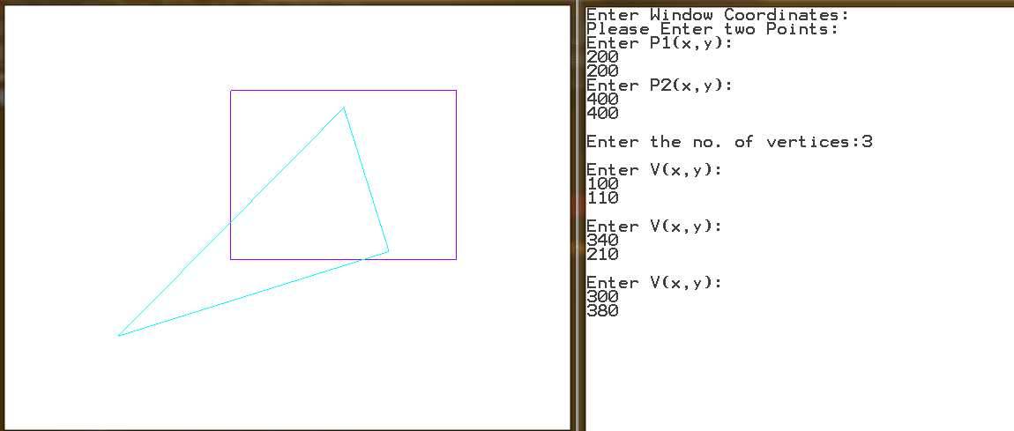

**After Clipping:**

